CTM-I Use Case

Wire Authorization

Version 0.1

Use Case Name | Wire Authorization
Actor | Firm User, Market Ops, Ops, App Support
Pre-conditions /Assumptions | User has Browser and is aware of the http path to the application.  User has successfully logged into the CTM-I application.  User has the right role to see the menu options.
Post Conditions | None
Screenshot | 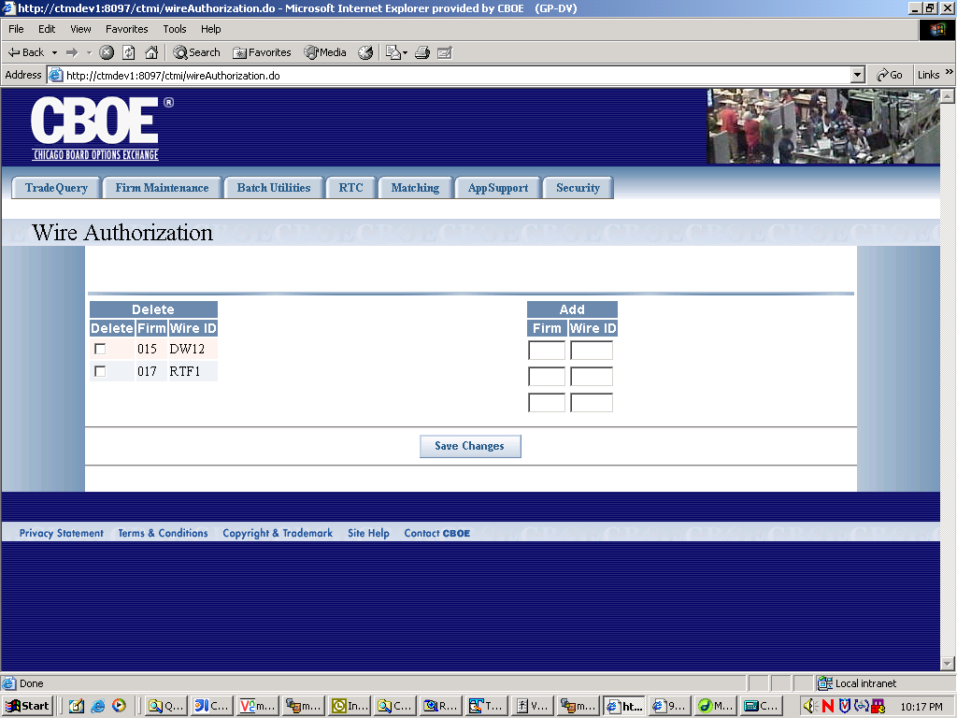
Flow of Events | - User selects “Wire Authorization” from the menu.  - Request is made to CTM-R for all wire authorization data  - Wire Authorization screen appears populated with the data  - The data show on each row will be as follows  - Delete (Yes or No only)  - Firm (display only)  - Wire Id (display only)  - Add firm, value validated by CTM-R  - Wire ID  - User can delete or add new firm wire authorization data and save the changes by pressing the “save changes” button  - Send the data to CTM-R to process  - Results of the CTM-R processing will display on the screen  - Once the changes are saved successfully, the search criteria will be sent to CTM-R to refresh the search results  - All rows of the table will be displayed, no paging will be done
Alternative Path

